Manifest Generation

# Revision

Version 3

3/13/24 10:10 AM

# Author

Charles Wilson

# Abstract

This document describes the process used to generate the vehicle manifest.

# Group / Owner

DevOps / Information Systems Security Developer

# Motivation

This document is motivated by the need to adopt best practices regarding creation of vehicle manifests, to allow for certification of compliance to standards such as **ISO/SAE 21434** and **ISO 26262**.

**Note:** This document is not subject to certification body review.

# License

This work was created by **Motional** and is licensed under the **Creative Commons Attribution-Share Alike (CC BY-SA-4.0)** License.

[**https://creativecommons.org/licenses/by/4.0/legalcode**](https://creativecommons.org/licenses/by/4.0/legalcode)

# Overview

The vehicle manifest is a comprehensive listing of all software in the vehicle. Given the complexity of autonomous vehicles, the manifest represents not only simple embedded systems, but also highly complex sensors and server-class system computers. The manifest organizes a collection of Software Bills-of-Material (SBOMs).

The following diagram illustrates the process to be used in the creation of the manifest:

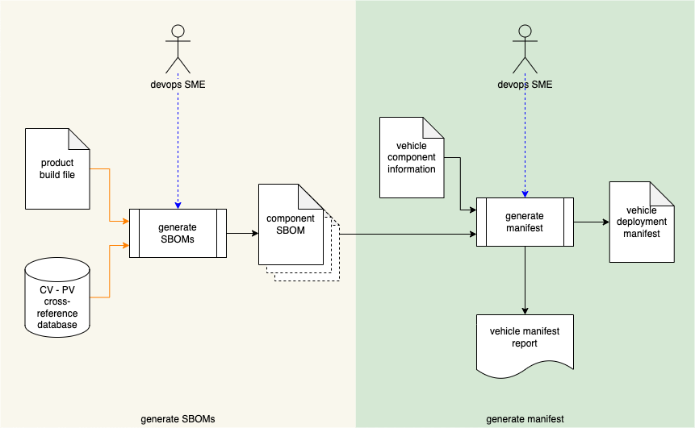

**Note:** The overall SBOM lifecycle is addressed in **Software Bill of Materials** **[1]**.

# Process

## Generate SBOMs

|  |  |
| --- | --- |
| **Inputs** | Product build file  Component / version – product / version cross-reference database |
| **Outputs** | Component SBOM(s) |
| **Participants** | Devops SME (optional) |

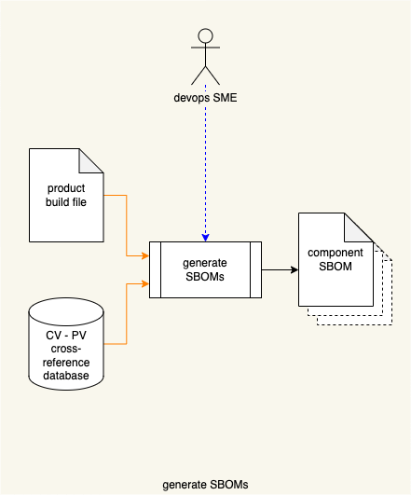

Using the **product build file** and the **component / version – product / version cross-reference database [2]**, SBOMs are generated. This operation may be fully automated or performed by a devops SME. The output of this process is a set of **component SBOM**s.

**Note:** Specific tooling **[5, 6]**, formats (**SPDX [7]**, **SWID [8, 9]**), and embodiments (**XML**, **JSON**) of the SBOM are not the subject of this document.

## Generate Manifest

|  |  |
| --- | --- |
| **Inputs** | Component SBOM(s)  Vehicle component information |
| **Outputs** | Vehicle deployment manifest  Vehicle manifest report |
| **Participants** | Devops SME (optional) |

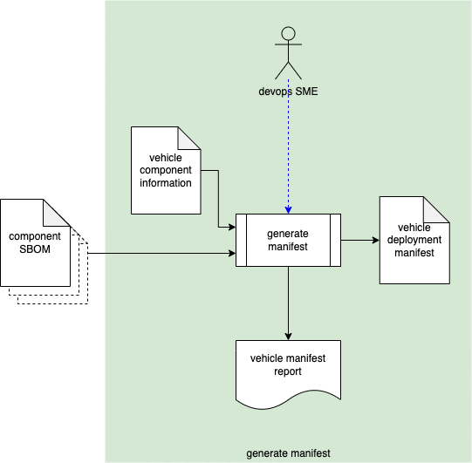

Using the **component SBOM**(s) and **vehicle component information**, a manifest is created. This operation may be fully automated or performed by a devops SME. The result is a **vehicle deployment manifest**. A **vehicle manifest report** is generated.

**Note:** The format and embodiment of the **vehicle deployment manifest** is not addressed in this document.

# References

1. **Software Bill of Materials** (AVCDL elaboration document)
2. **Component / Version – Product / Version Cross-reference Document** (AVCDL secondary document)
3. **Code Protection Plan** (AVCDL secondary document)
4. **SOFTWARE BILL OF MATERIALS**[**https://www.ntia.gov/SBOM**](https://www.ntia.gov/SBOM)
5. **Tooling Ecosystem working with SPDX**  
   [**https://docs.google.com/document/d/1A1jFIYihB-IyT0gv7E_KoSjLbwNGmu_wOXBs6siemXA/edit**](https://docs.google.com/document/d/1A1jFIYihB-IyT0gv7E_KoSjLbwNGmu_wOXBs6siemXA/edit)
6. **Tooling Ecosystem working with SWID**  
   [**https://docs.google.com/document/d/1oebYvHcOhtMG8Uhnd5he0l_vhty7MsTjp6fYCOwUmwM/edit**](https://docs.google.com/document/d/1oebYvHcOhtMG8Uhnd5he0l_vhty7MsTjp6fYCOwUmwM/edit)
7. **Software Package Data Exchange® (SPDX®)**  
   [**https://spdx.dev/wp-content/uploads/sites/41/2017/12/spdxversion2.1.pdf**](https://spdx.dev/wp-content/uploads/sites/41/2017/12/spdxversion2.1.pdf)
8. ISO 19770-2:2015 **Information technology - IT asset management - Part 2: Software identification tag**[**https://www.iso.org/standard/65666.html**](https://www.iso.org/standard/65666.html)
9. NIST IR 8060 **Guidelines for the Creation of Interoperable Software Identification (SWID) Tags**  
   **<https://nvlpubs.nist.gov/nistpubs/ir/2016/NIST.IR.8060.pdf>**